Project 2

# Abstract

The single-phase DC-AC inverter are circuits that allow from DC Voltage to AC Voltage conversion. This means the DC source voltage would be converted to an AC load voltage. The purpose of the inverter is the change the DC input to the desired AC magnitude and frequency. This desired AC waveform should be as close to sinusoidal behavior as possible, however as we will explore, the inverter conversion results in some harmonics which will affect the output of the nature of the waveform. These harmonics can lead to problems in real life such as filtering for audio amplification or the motor speed of ac motors varying due to the various frequency harmonics. Along with single-phase, three-phase inverters are used in applications where there are three outputs needed with a respective offset from one another. The offset is usually a phase with 120 degrees. This ensures that the waveforms are never turned on with respective to each other. This also means the waveform is turned on for 120 degrees of the total 360 degrees. This type of application would be in three-phase motors where we can use such currents to create back emf and generate regenerative braking to slow the motor down.

# Theory

The basic driving factor of the circuit is the switching of the switches to generate the needed AC waveform. The H-bridge converter allows us to do so by taking the output V_AC between the poles of phase leg A and phase leg B. The AC output is derived by closing and opening the switches for 180 degrees of the output in a necessary manner. The output voltage would be either V_dc or -V_dc depending on if S1 and S2 are closed or if S3 and S4 are closed. Additionally, the output can also go to zero when S1 and S3 are closed or when S2 and S4 are closed since the Vout is just shorted to itself. Additionally, we also need to keep in mind that S1 and S4 should never be closed at the same instance, nor should S2 and S3 since this would be causing a short across the source. The diode current consists of the switch current when the switch current would be negative and the transistor current is the switch current when it is positive. We can also use the transistor current to plot our I_dc since it would be only passing through when it is positive. Finally, the total harmonic distortion can be found by finding the RMS values of the waveform. The THD function uses the initial RMS coefficients and compares it to the sum of the rest of the coefficients squared square rooted. We can plot these c_k harmonic distortions against the frequency space to see how our harmonics result as we increase frequency.

# Results

1. Graphical user interface, text, application

   Description automatically generated
2. Graphical user interface, text, application

   Description automatically generated
   1. Looking at the waveforms, I see that as the number of terms increases, the Fourier can match the input much better. At an input of 50 terms, we finally match the Fourier to the original waveform. At inputs of 5 terms, we just get a normal sine wave which is barely matching the input. Additionally, if we run the harmonic THD function on this code, we find that the THD for it is 3.59 which is around 359%. I would say this is due to the fact that Fourier is mostly meant for square waves in which we are trying to input so many cosines and sine waves, which is mostly the result of the harmonics.
3. Text

   Description automatically generated with medium confidence
4. This circuit was simulated using the equations from the textbook: Diagram

   Description automatically generated

This is the results I_ac when t < T/2 which is the first half of the period and t > T/2 which is the second half of the period. Using this I_ac eqation, we can approximate the values using a for loop. Additionally section 8.2 in the book highlights that when S1 and S2 are closed, the output is V_ac and when S3 and S4 are closed, the output is -V_dc.

For Loop:

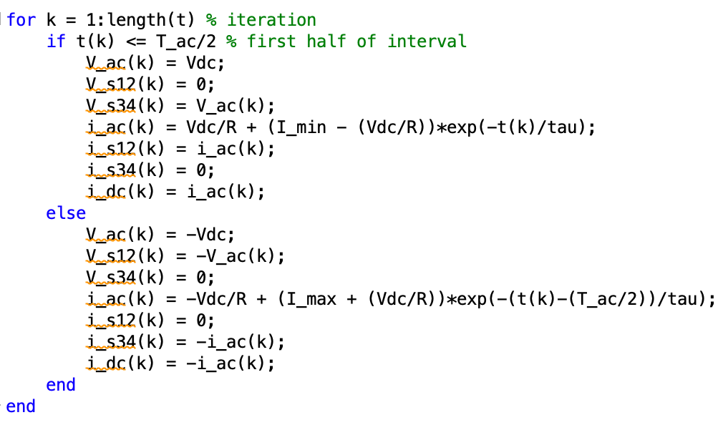

Transistor and diode currents:

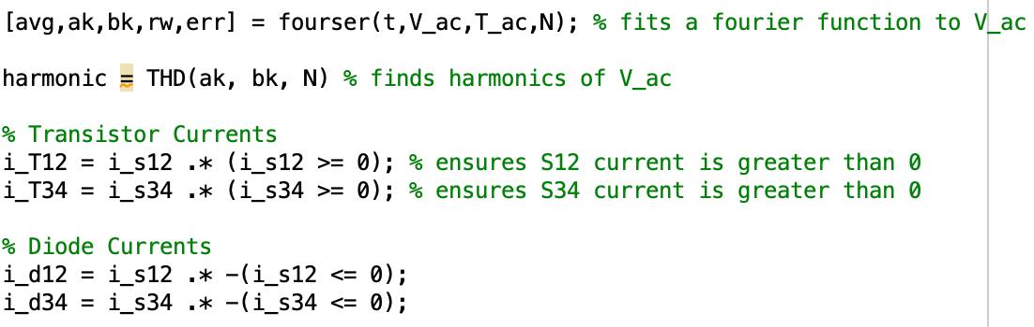

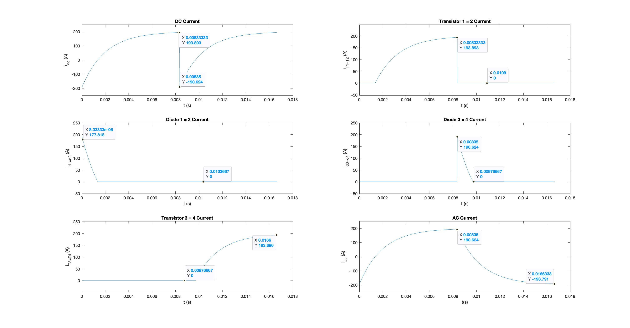Plots:

Harmonic = 46.59 %

1. This circuit was simulated using equations from backwards Euler’s and switching logic:

Givens:

Initializations:

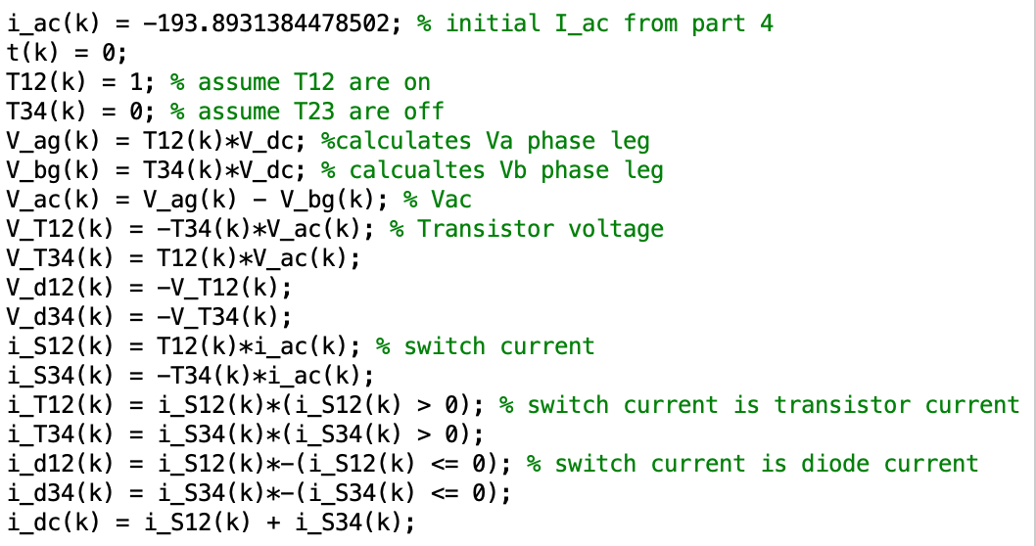

Eulers:

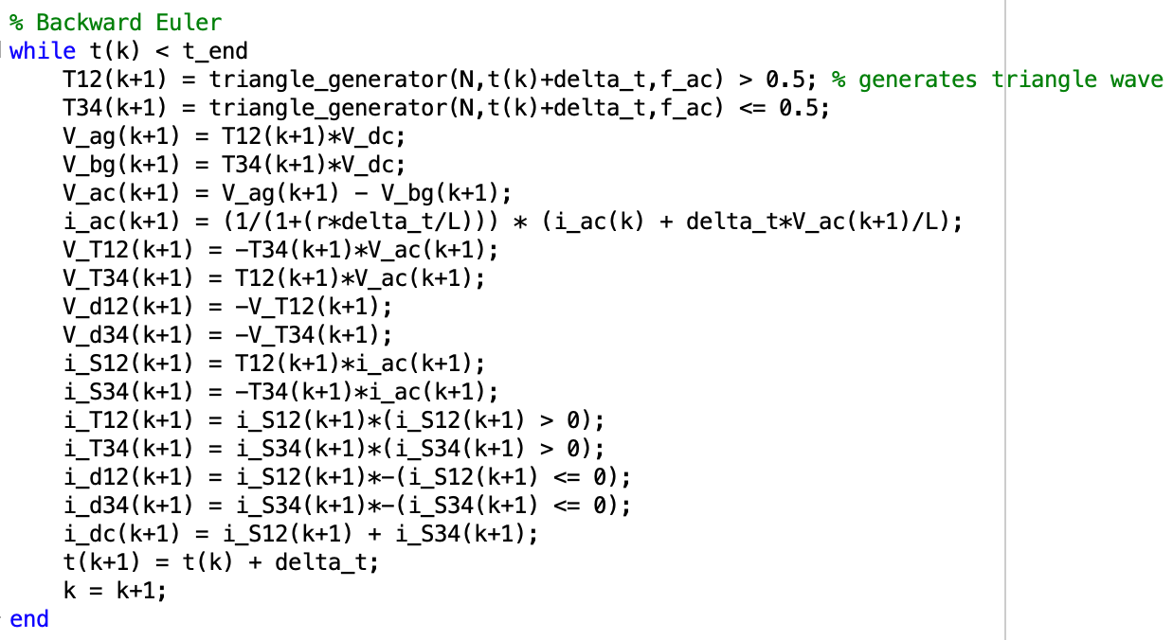

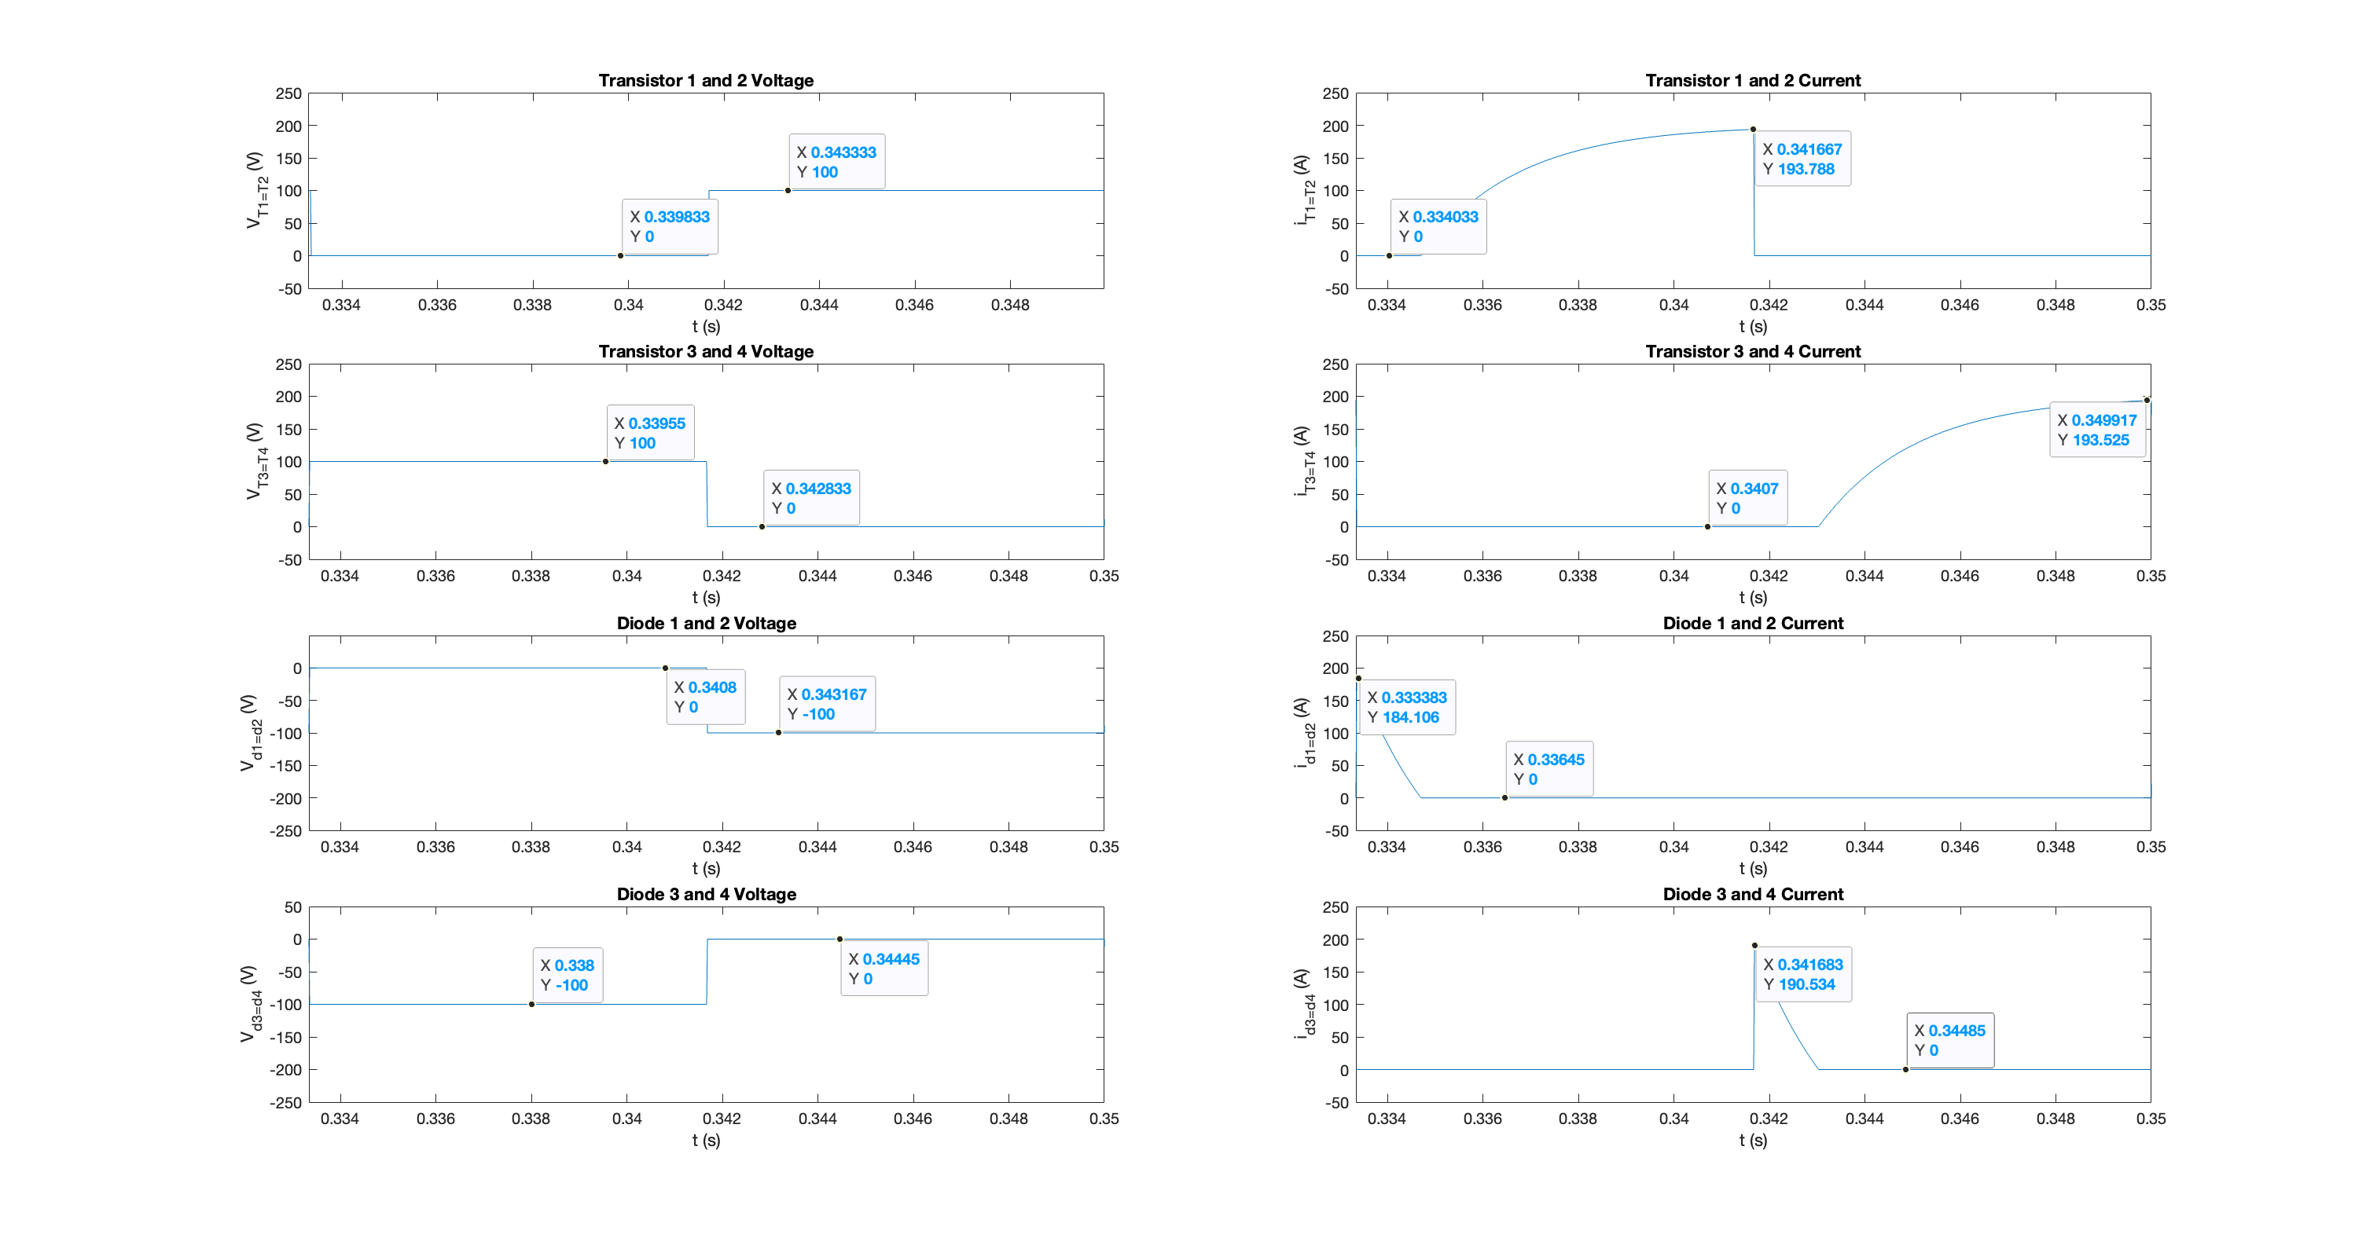

Harmonics = 46.88%

Comparing task 4 to task 5, we see that the results are nearly identical for 180 degree switching. Using a triangle wave, we can turn on for half the period of the f_ac, we can assign each portion of the interval to a switching state. The steady state voltage would be the difference between the phase legs of the h-bridge circuit. This was nearly equal to Vdc or -Vdc determined by the switching. The steady state minimum current found from Euler’s method was nearly equal to the -193 A that we received in task 4 by simply determining the value of the I_min and I_max and the switching of the intervals. We also need to determine the transistor currents by looking at the phase leg current and determining its magnitude with respect to zero. A positive current means the transistor is conductive while vice versa for diodes. Looking at the frequency spectrum, we see that for multiples of our w_ac, the harmonic is very high. As a result, the THD resulted in 46.88 percent which is around the expected 40% THD from this circuit as discussed in the textbook. Additionally, I find that at the fundamental frequency, the output is the expected 127 Volts from part 4 because this would be the frequency that we would want to pass. The higher frequency harmonics can be filtered out as we find later.

1. This circuit was simulated using sine triangle modulation and a comparator was compared against the triangle wave to generate the switching of the h-bridge inverter. After receiving a square wave from V_AC, the LC filter removes the higher harmonics with its cutoff being 440 Hz for the musical note ‘A’. Using the equation for the derived transfer function, H(s) = , we can pick an inductor or capacitor value to find the needed other component. The inductor selected was 1 mH and using the cutoff frequency, we can find the capacitor value to be around 2 uF. The input was given at 1 kW so this can be taken at the RMS voltage output and resistor to get the input for Vdc. Vdc would be a function of the comparator: V_dc = (1/m) * sqrt(8000) * sqrt(2). The m would be 0.95 since the ‘A’ is played at that sinewave.

Harmonics: 5.22%

After simulating the circuit, we see that the harmonics were eliminated for frequencies above 440 Hz because that is the cutoff for our LCR filter. Additionally, the diodes and transistor currents seem that the switching is occurring too fast so it is resulting in a zig-zagged line. Taking the fast average of this would fix the issue and result in a cleaner waveform. Finally, we see the output of the Vout is a sinusoidal waveform which is as expected for the speaker. The sinusoidal is at the frequency of 440 Hz and we can take the Fourier series of it to find the harmonics in the waveform. The harmonics resulted in 5% error due to selecting the inductor and capacitor values appropriately. Additionally, the output from Vac is a square wave because the output is either Vdc or -Vdc which is calculated in the theory section using the formula. Similar to how we used the frequency of the desired ac waveform in q5, we set up the triangle function to equal half the interval with S1 and S2 on while S3 and S4 are off.

1. The calculated duty cycle values from the given power is sqrt(8*Pout)*sqrt(2)/V_dc = d. This is found from the RMS Vout/R and the original V_dc for d = 0.95 which was around 133.3 V. This would mean the m = [0.3004 0.4249 0.5203 0.6008 0.6718 0.9500]. We can plug each value of m in to get the amplitude as a function of m from part 6.

|  |  |  |
| --- | --- | --- |
| m | Pout | fundamental |
| 0.3004 | 100 | 38.4228 |
| 0.4249 | 200 | 54.2272 |
| 0.5203 | 300 | 65.9464 |
| 0.6008 | 400 | 76.3693 |
| 0.6718 | 500 | 85.3511 |
| 0.9500 | 1000 | 120.8963 |

Here we see that up until m = 1, the duty cycle is a linear relationship of the fundamental that is resulting from the circuit. This would be true until m = 1, where the saturation and 180* degree switching period come into play and the fundamental becomes a function of the m: f(m) * V_dc = fundamental.

1. A picture containing text

   Description automatically generated

Here the Vag, Vbg, and Vcg values are created with a phase offset of 2pi/3 and then the respective relationships for 2/3*Vxg – 1/3*Vxg – 1/3*Vxg for each respective phase voltage. The switching statement was unable to be determined due to the logic of the triangle function that was created. Therefore, none of the diodes and transistor voltages were available for us to explore. We expected the relationship for the transistor and diodes currents to be like the single-phase inverter in which if the switch current is negative, the diode is conducting and when the switch current is positive, the transistor is conducting. The Vas bs cs values were all approximately 2pi/3 phase shifts off due to the input from the duty cycle. The switching could have been further explored by checking for x-intercept of the first derivative of ias bs cs to control T1,T4 T2,3 T5,6

# Conclusion

In this project, I simulated a DC-AC inverter under 180 degrees switching and sine triangle modulation. The 180 degree switching results were nearly identically to the one derived in task 4 using the book’s equations. Both circuits result in harmonics at higher than the fundamental frequency however in the sine-triangle, we used a LCR filter to take the higher harmonics out. The 180-degree switching resulted in a THD of around 48% while the sine triangle, with its LCR filter, resulted in a THD of around 5%. This is close to the needed 1% that was desired however this was not obtained due to the tolerances of the L and C values along with the harmonic not completing equaling zero. As the power output was decreased the fundamental is also decreased because the duty cycle of the signal was decreased as a result V_out_rms would be lower. The fundamental resulted is much lower than the 1000 W however, we see the linear relationship from 0 < m < 1. Overall, the experiment can be considered a success due to the nature of the predicted and confirmed harmonics that have resulted for the single-phase inverter.